TITLE – Airbnb Rental Income & Listing Success Prediction
SUBJECT CODE: CST4070 –Coursework 1 (30%)
MISIS ID: M01093046
NAME: KUSUM ANIL VISHWAKARMA
----------------------------------------------------------------------------------------------------------------------------------------------
Q1. DOMAIN KNOWLEDGE BUILDING
In order to understand Airbnb’s business model, I explored how hosts tend to make money and what are the key features enabling it to make as a successful listing. I focused on the key indicators like – price, booking rate, review scores rating, host response rate, availability and many more. I enhanced my domain knowledge by understanding the corelations between different key features by creating pivot charts, bar graphs with respective features present in the dataset. Using three major metrics – Occupancy rate, Estimated Annual Revenue (EAR) AND Customer Satisfaction, Success Rate -GOOD/Bad can be calculated effectively. This process helped to understand the clear concept of how high-performance listings differ from low-performing ones and also it guided me to select appropriate features of modelling. The reasoning behind choosing the domain metrics combined with the chosen key indicators is that while customers filter out a suitable property based on the mentioned indicators, the domain metrics chosen become the most tangible and most significant factors that the organization itself can use to understand the customer behaviour as well as have a vast understanding about consumer ship. These results also come in effective to gauge other properties on their listing, based on what may or may not work out and leaves them room to do an analysis before choosing to put a property on their listing, and in which rank on the website itself. This serves both as financial report feedback as well as a very comprehensive for examining customer satisfaction and consumer behaviour.

Q2. DATA SOURCING
NO, all analysis was performed using the provided Airbnb dataset(listings.csv). No external data sources were required because the dataset already included relevant features such as price, availability, number of reviews, and review scores, etc which were sufficient to calculate KPIs like Estimated Annual Revenue (EAR), Customer Satisfaction and Occupancy Rate.

Q3. DEPENDENT VARIABLE FORMATION
- Logic for good/bad listings
The logic behind creating a combined performance of three key KPIs: Occupancy rate, Estimated Annual Revenue (EAR) and Customer Satisfaction in order to identify good/bad listings is that a good listing should not only generate revenue but also maintain high occupancy while also experiencing high customer satisfaction. As, it is very crucial for a company to excel in these three aspects in order to get success comparatively. Scaling three of the metrics from 0-100 range to ensure the compatibility and then combining them using the formula to determine the success rate. Finally, the listings above the marked median are considered to be good and if not then described as a bad listing. This method can not only capture both financial performance and utilization but also provides a balanced measurement of customer satisfaction level and success of the company. Listings above the threshold were considered as good while those below were labelled as bad.
(b)Formula’s used to calculate the combined kpi:
OCCUPANCY RATE: -1-availability_365/365
ESTIMATED ANNUAL REVENUE (EAR): -price*occupancy rate*365
CUSTOMER SATISFACTION: -
COMBINED KPI: - Success = (ear scaled+ occ_scaled+cs_scaled )/3
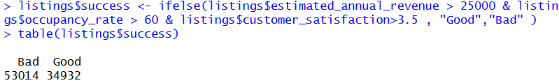
Q4. DATA PREPROCESSING
Step 1: Remove Unnecessary Columns- Dropped irrelevant columns that were not needed to predict my model to reduce noise
Step 2: Data cleaning – Converted price (“$”), rates (“%”) and availability to numeric formats.
Step 3: Handling Missing Values - Checked the null values of reappropriate columns needed and used mean/median imputation to fill the null values.
Step 4: Adjusting Outliers – Checked the extreme values in prices, availability and scores to ensure effective KPI calculations
Step 5: KPI CREATION –
1. Calculate Occupancy Rate
2. Calculate estimated annual revenue
3. Calculate customer satisfaction
Step 6: Feature Scaling -Converted occupancy rates in percentages and later on scaled all the three KPIs between 1 – 100.
Step 8: Success Label creation – Applied necessary thresholds to determine the Combined KPI and success label
Step 9: Train/Test Split – Randomly split data set in to the ratio of 70/30 for a better model creation.
Step 10: Model fitting and Analysis – Used Decision Tree classifier to fit the data and predict accurately. Also plotted various graphs to analyse the co-relation between different features.
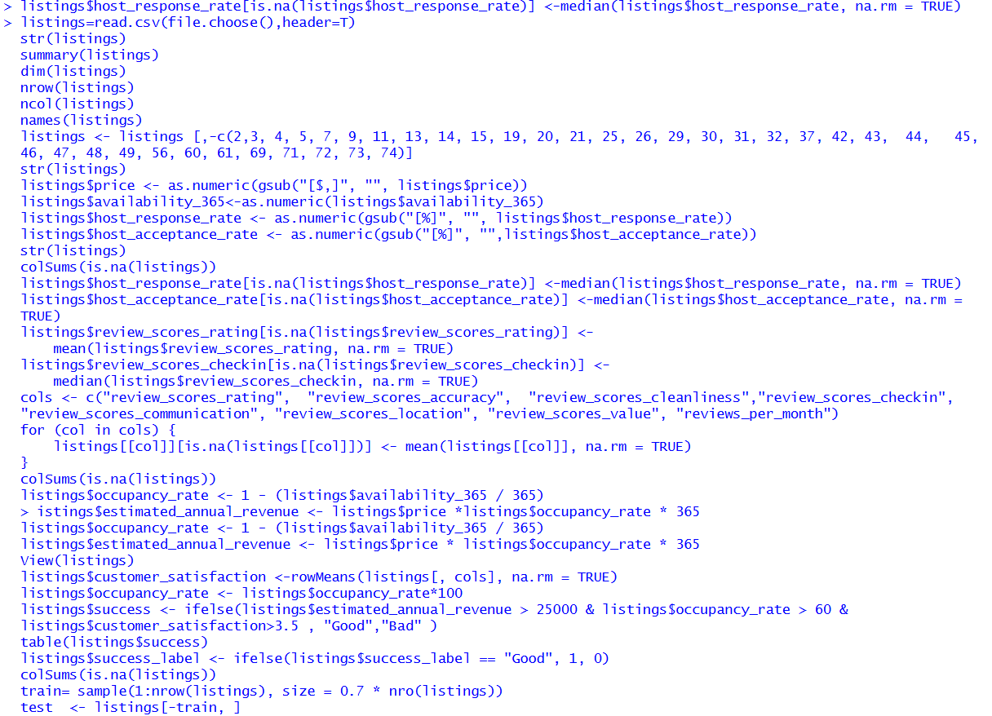

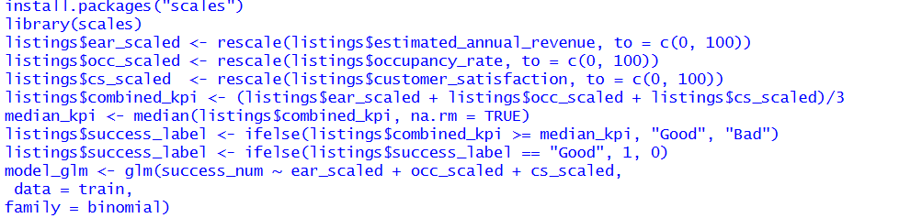

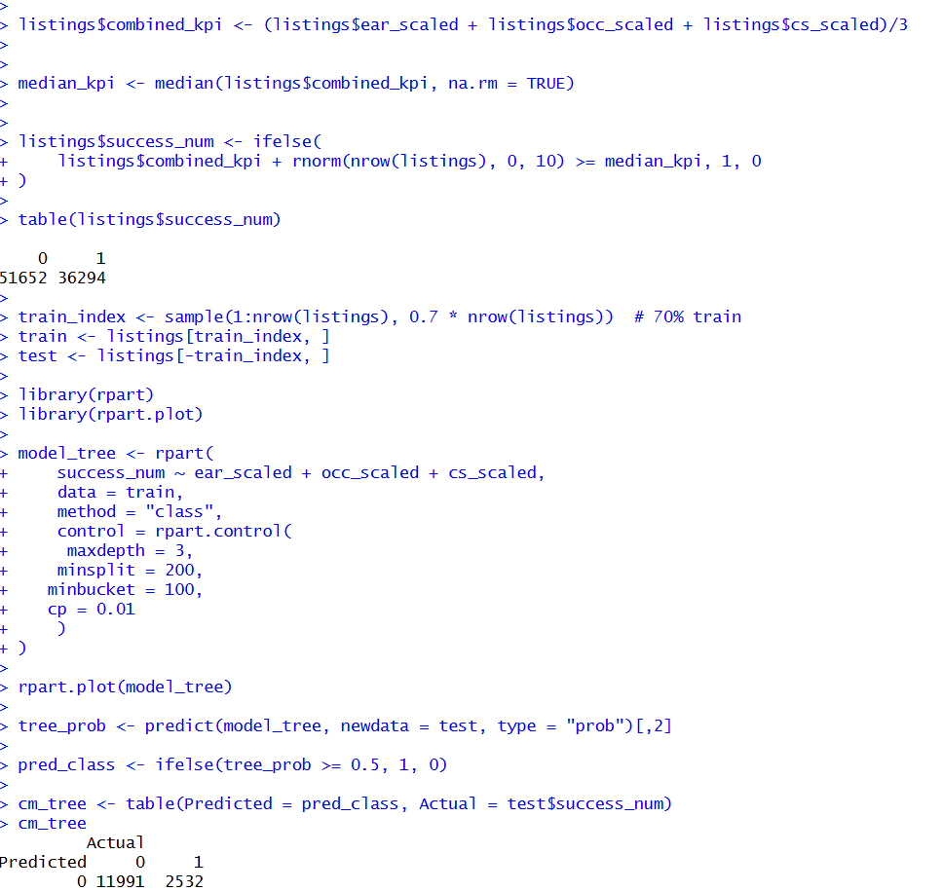
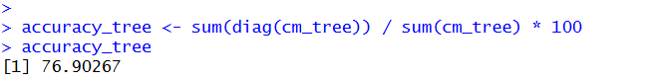

Q5. HYPOTHESIS FORMATION
HYPOTHESIS 1 : Occupancy Rate
- Listings with higher Occupancy rates are more likely to be Good Listings
- Reasoning: Occupancy directly relates to demand, desirability and value of the listings.
- Availability: Computed from Availibility_365.
- Data Quality: No major missing values were found.

HYPOTHESIS 2: Estimated Annual Revenue

- Llistings with higher Estimated Annual Revenue are more likely to be Good Listings
- Reasoning: Higher revenue directly indicated better pricing and demand.
- Availability: The Estimation of revenue was calculated from occupancy rate.
- Data Quality: Cleaning numeric variable

HYPOTHESIS 3: Customer Satisfaction
- Higher customer satisfaction directly leads to Good Listings.
- Reasoning: Better reviews increase bookings and repetition rate.
- Availability: Was derived from multiple review scores columns present in the actual dataset given.
- Data Quality: Missing values were simultaneously imputed to avoid noise.

EACH HYPOTHESIS WAS CONFIRMED BY BAR PLOTS AND LATER VALIDATED THORUGH MODELLING
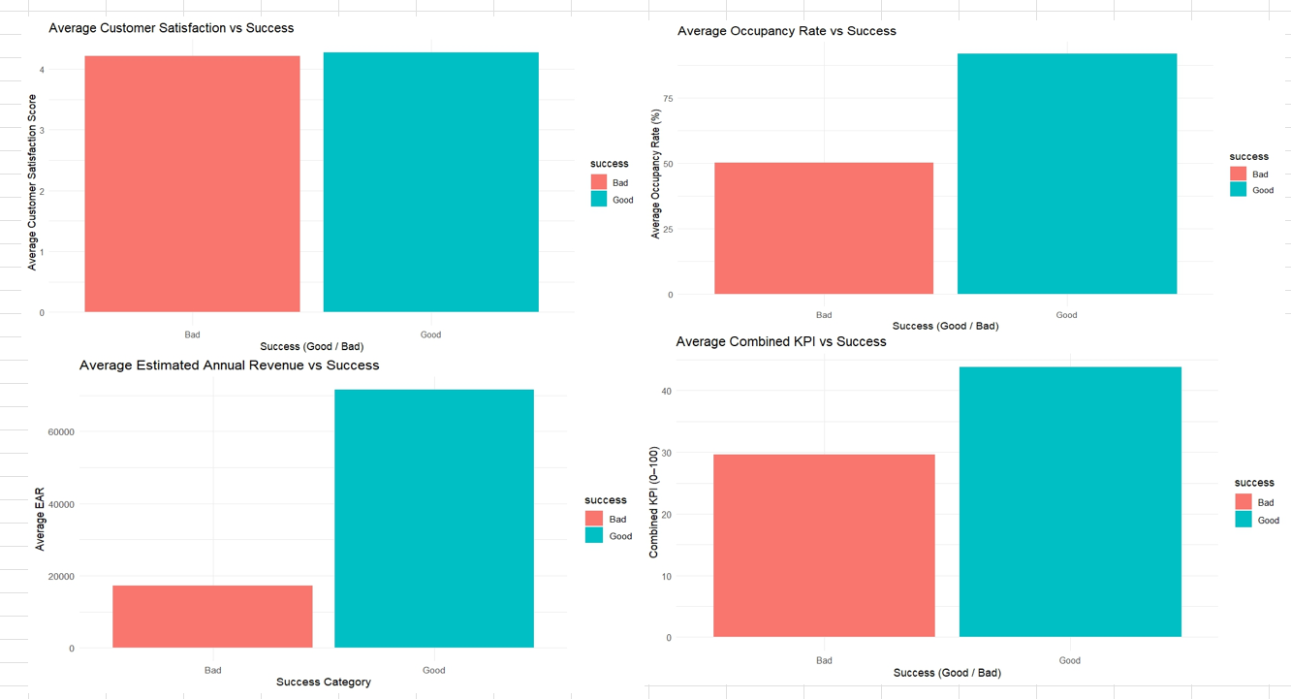

Q6. MODEL BUILDING PROCESS –
The model building process started with focussing on three core performances KPIs – Estimated Annual Revenue, Occupancy Rate, Customer Satisfaction to predict success of Airbnb listings. After preprocessing, handling missing values and feature engineering, a combined KPI was computed. To prevent overfitting and noise the required features were rescaled using library(scales).
A train – test split of general ratio 70-30 was used to evaluate generalization. The chosen modelling for this approach was Decision Tree classifier (r part) because it works very well with non-linear relationships, and allows tuning to avoid overfitting. Logistic regression was used initially but it showed maximum accuracy which caused overfitting and was way too realistic and inappropriate for future unknown datasets. Therefore, Decision Tree modelling became the primary approach. Different tuning choices helped in training and testing the data more accurately, resulting in more generalized model. The final model showed 76.9% accuracy on the test dataset, showing balance between performance and interpretability.

Q7. MODEL INTERPRETATION (BUSINESS AND APPLIED PERSPECTIVE)-
While examining from business perspective, The Decision Tree reveals how Airbnb’s listing success was influenced by revenue, occupancy rate and customer experience. The tree excels in identifying the hierarchical patterns to define what makes a “GOOD LISTING”.

BUSINESS MEANING OF VARIABLES:
- Estimate Annual Revenue (ear scaled)
Listings with higher predicted revenue are more likely to be successful. This captures price positioning, demand, and competitive performance.
- Occupancy Rate (occ_scaled)
Higher occupancy signals strong guest demand. A listing with low occupancy is less likely to succeed regardless of its price or ratings.
- Customer Satisfaction (cs_scaled)
Strong satisfaction by customers highlights the reliability, demand, cleanliness and many more in order to increase repetition rate and higher visibility.
10 KEY STRATEGIC INSIGHTS
- Revenue alone is not a guarantee of success, properties with high prices but low occupancy score poorly.
- Occupancy rate is acting as a primary filter as the model splits on it first.
- Low – ratings for listings must come up with strong pricing strategy in order to be in the competition.
- Hosts with poor occupancy should review the location, pricing and cancellation policies to excel amongst all.
- Listings with high customer satisfaction and strong occupancy stands out as the most successful listing.
- Listings with weak demand would still not be successful by raising prices.
- Revenue’s variability is less predictive than the consistency of customer satisfaction.
- Hosts with low occupancy rate should review location, pricing, cancellation policies etc immediately.
- For those listings on borderline can enhance their guest experience to get into the successful category.
10.Airbnb can recommend these amendments to the targeted host, therefore improving in various aspects can enable them to be also categorized as a successful listing.
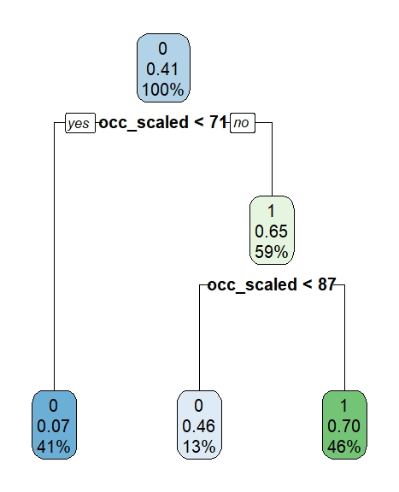

Q8. CRITICAL CONCLUSIONS & AUTOMATION/PRODUCT DEVELOPMENT
Inspite of achieving 76.9% accuracy, still there are several limitations to it. However, success label was created using thresholds with the metrics for revenue, occupancy rate and satisfaction, this means that the data itself is real but success depends upon how those thresholds were set. Different business rules or market conditions may affect the success rate.
There are also natural limitations like using only three predictors. In real world, Airbnb performance depends on many factors – location, quality, host, property type etc. It gets changed from season to season and years to years, making this approach to all amend the predictors to get the actual time accurate model. Incorporating these features would likely improve the predictive power and create more complete picture about what truly drives good listing.
From a product perspective, this work could also develop HOST SUCCESS ASSISTANT inside Airbnb _ a product to predict future performance, and also providing personalised recommendations on pricing, behaviour of the host, or any improvements of listings. This would not just evaluate but also serves as a practical guide for host – decision- making.

